14.76: a) The change in pressure with respect to the vertical distance supplies the force necessary to keep a fluid element in vertical equilibrium (opposing the weight). For the rotating fluid, the change in pressure with respect to radius supplies the force necessary to keep a fluid element accelerating toward the axis; specifically, 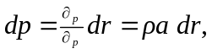and using 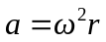 gives 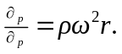 b) Let the pressure at 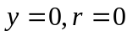be 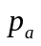(atmospheric pressure); integrating the expression for 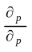 from part (a) gives

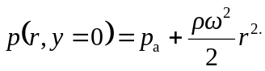

c) In Eq. 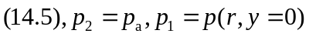as found in part (b), 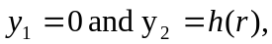 the height of the liquid above the  plane. Using the result of part (b) gives 